K3 Supply List:
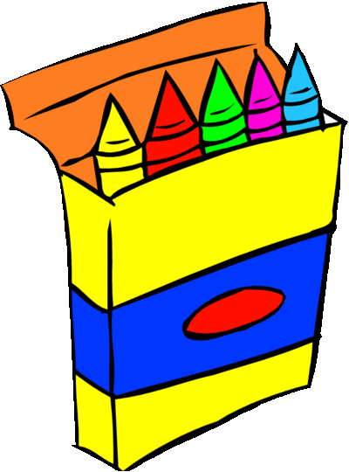
3 Baby Wipes, Unscented, 64 ct Huggies© Soft Pack
1 Crayons, 8 ct, Crayola©, Large
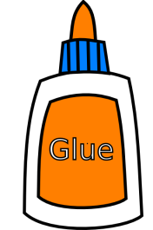
3 Glue Stick, Small, Elmer’s©, .21 oz
1 Glue, Small, Elmer’s©, 4 oz, Wash, White
1 Marker, Crayola©, Classic, Broad, Washable, 8 ct
1 Paper, Copier, 8.5 x 11 Ream, White
1 Tissue, Kleenex©, Family Size
1 Large Backpack (NO WHEELS)
1 Old T-shirt (No button downs)

K4 Supply List:
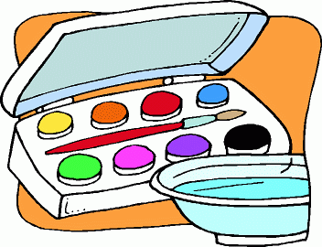
1 Crayons, 24 ct, Crayola©
2 Folder, Design, Assorted
4 Glue Stick, Large, Elmer’s©, .77 oz
3 Glue, Small, Elmer’s©, 4 oz, Wash, White
3 Markers, Crayola©, Classic, Broad, Washable, 8 ct
1 Markers, Crayola©, Classic, Fine, Washable, 8 ct
2 Paper, Copier, 8.5 x 11 Ream, White
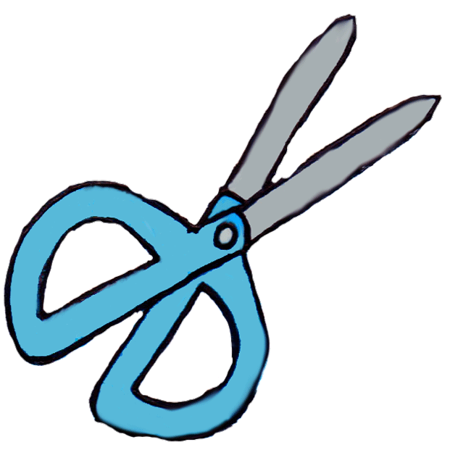
1 Scissors, 5” Blunt (round)
2 Tissue, Kleenex©, Family Size
1 Watercolors, 8ct Crayola©, Washable
2 Wipes, Clorox©, Disinfectant, 35 ct
1 Large Backpack (NO WHEELS)
1 Dinner Size Paper Plates, 50ct
1 Box Ziploc© Bags (Sandwich, Quart, or Gallon Size)
1 Paint Shirt: Old t-shirt

K5 Supply List:
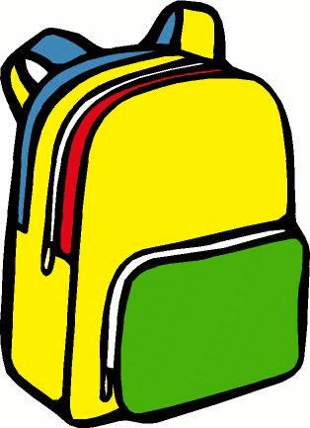
1 Crayons, 24 ct Crayola©
2 Folder, Design, Assorted
4 Glue Stick, Small, Elmer’s©, .21 oz
3 Glue, Small, Elmer’s©, 4 oz, Wash, White
3 Markers, Crayola©, Classic, Broad, Washable, 8ct
2 Markers, Crayola©, Classic, Fine, Washable, 8ct
1 Mat, Rest, Basic, 5/8x19x45 4-fold (optional)
2 Paper, Copier, 8.5x11 Ream, White
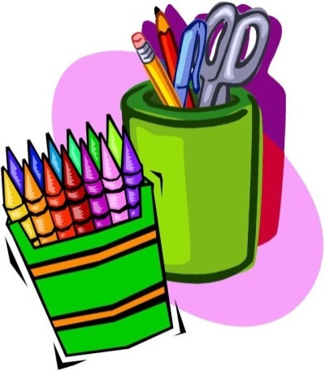
1 Scissors, 5” Blunt (round)
2 Stickers, Regular, Package
2 Tissue, Kleenex©, Family Size
1 Watercolors, 8ct Crayola©, Washable
3 Wipes, Clorox©, Disinfectant, 35ct
1 Large Backpack (NO WHEELS)
1 Old T-shirt (No Button Downs)
1 Dinner Size Paper Plates, 50ct

To be purchased at school: Headphones $5.00

1st Grade Supply List:
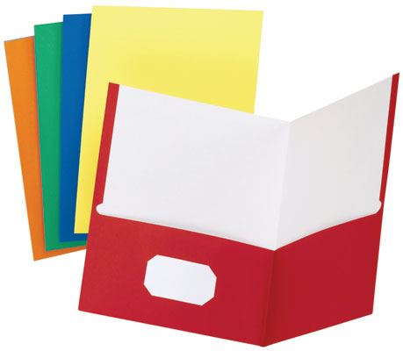
3 Case, Pencil, Soft Pouch, Zippered
1 Crayons, 24 ct, Crayola©
2 Eraser, Large Pink
1 Folder, Laminated, 2 pocket w/ fasteners, Assorted
3 Folder, Laminated, 2 pocket, Assorted
2 Glue Stick, Large, Elmer’s©, .77 oz
2 Glue, Large, Elmer’s©, 7 5/8 oz, Wash, White
2 Markers, Crayola©, Classic, Broad, 8ct
1 Markers, Crayola©, Classic, Fine, 8ct
1 Notebook, 70 pg, Wide, Asst, Spiral
2 Paper, Copier, 8.5x11 Ream, White
12 Pencil, #2, Ticonderoga ©, Sharpened, Yellow
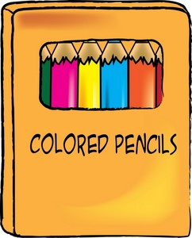
1 Pencils, Colored, 12 ct, 7” (Long), Crayola©
1 Scissors, 5” Pointed
2 Sharpie©, Black, Fine
1 Shoe Box, Plastic, w/Lid (6qt)
2 Stickers, Regular, Package
2 Tissue, Kleenex, Family Size
2 Watercolors, 8ct, Crayola©, Washable
2 Wipes, Clorox©, Disinfectant, 35ct
1 Smock (old T-shirt, no buttons)
1 Backpack (NO WHEELS)

To be purchased at school: Headphones $5.00 (New Students Only)

2nd Grade Supply List:
1 Case, Pencil, Soft Pouch, Zippered
1 Crayons, 24ct, Crayola©
2 Eraser, Large Pink
4 Folder, Laminated, 2 pocket, Assorted
2 Glue Stick, Large, Elmer’s©, .77 oz
1 Glue, Large, Elmer’s©, 7 5/8 oz, Wash, White
1 Markers, Crayola©, Classic, Broad, 8ct
1 Markers, Crayola©, Classic, Fine, Washable, 8ct
1 Notebook, 70 pg, Wide, Asst, Spiral
2 Paper, Copier, 8.5x11 Ream, White
2 Pen, Red, Erasable, EraserMate©
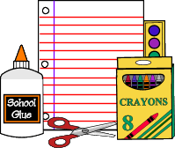
12 Pencil #2, Ticonderoga©, Sharpened, Yellow
1 Pencils, Colored, 12 ct, 7” (Long), Crayola©
1 Ruler, 12” Standard & Metric, Clear Plastic w/Holes
1 Scissors, 5” Pointed
1 Shoe Box, Plastic, w/Lid (6qt)
2 Tissue, Kleenex©, Family Size
1 Watercolors, 8ct, Crayola©, Washable
2 Wipes, Clorox©, Disinfectant, 35ct
1 Smock (old T-shirt, no buttons)
1 Backpack (NO WHEELS)

To be purchased at school: Headphones $5.00 (New Students Only)

3rd Grade Supply List:

1 Binder, 1 ½”, White, Clear View, Durable
3 Book Cover, Fabric, Regular
1 Case, Pencil, Soft Pouch, Zippered
1 Crayons, 24ct, Crayola©
2 Dry Erase Marker, Black Chisel Tip, Expo 2©
1 Eraser, Large Pink
4 Folder, Laminated, 2 pocket, Assorted
4 Glue Stick, Large, Elmer’s©, .77oz
1 Glue, Large, Elmer’s©, 7 5/8 oz, Wash, White
1 Markers, Crayola©, Classic, Broad, 8ct
1 Markers, Crayola©, Classic, Fine, 8ct
3 Notebook, 70pg, Wide, Asst, Spiral
2 Paper, Copier, 8.5x11 Ream, White
4 Pen, Red, Bic©, Ballpoint Stick

10 Pencil, #2, Ticonderoga©, Sharpened, Yellow
1 Pencils, Colored, Erasable, 10ct, 7” (Long), Crayola©
1 Scissors, 7”, Student Schoolworks by Fiskars©
1 Shoe Box, Plastic, w/Lid (6qt)
1 Tape, Invisible, ¾” x 300”
2 Tissue, Kleenex©, Family Size
1 Watercolors, 8ct, Crayola©, Washable
1 Wipes, Clorox©, Disinfectant, 35ct
1 Smock (Old T-shirt, no buttons)
1 Backpack (No wheels)
1 Folder & Pencil for Tech

To be purchased at school: Headphones $5.00 & Assignment Notebook $4.50

4th Grade Supply List:
6 Book Cover, Fabric, Jumbo
1 Crayons, 24 ct, Crayola©
1 Dry Erase Marker 4pk, Chisel Tip Expo 2©
1 Eraser, Large Pink
1 Eraser, Pencil Cap, Latex Free, 10ct
4 Folder, Laminated, 2 pocket, Assorted
4 Glue Stick, Large, Elmer’s©, .77 oz
1 Glue-All, Large, Elmer’s©, 7 5/8 oz
1 Markers, Crayola©, Classic, Broad, 8ct
1 Markers, Crayola©, Classic, Fine, 8ct
4 Notebook, 70pg, Wide, Asst, Spiral
2 Paper, Copier, 8.5x11 Ream, White
2 Paper, Looseleaf, Wide Rule, 200ct
2 Pen, Red, Bic©, Ballpoint Stick

24 Pencil, #2, Ticonderoga©, Sharpened, Yellow
1 Pencils, Colored, 12 ct, 7” (Long), Crayola©
1 Scissors, 7”, Students Schoolworks by Fiskars©
1 Shoe Box, Plastic, w/Lid (6qt)
2 Tissue, Kleenex©, Family Size
1 Watercolors, 8ct Artista (mfg by Crayola©)
2 Wipes, Clorox©, Disinfectant, 35ct
1 Smock (Old T-shirt, no buttons)
1 Backpack (no wheels)
To be purchased at school: Headphones $5.00 (New Students Only), Assignment Notebook $4.50, Recorder $5.50 (New Students Only)

5th Grade Supply List:
1 Crayons, 24ct, Crayola©
2 Dry Erase Marker, Black Chisel Tip, Expo 2©
2 Eraser, Large Pink
7 Folder, Laminated, 2 pocket, Assorted
4 Glue Stick, Large, Elmer’s, .77oz
3 Highlighter, Broad Chisel, Yellow
1 Index Cards, 3x5, Ruled, White, 100ct
1 Markers, Crayola©, Classic, Broad, 8ct
1 Markers, Crayola©, Classic, Fine, 8ct
6 Notebook, 70pg, Wide, Asst, Spiral
1 Notebook, Composition, Marble, Black, Wide, 100ct
2 Paper, Copier, 8.5x11 Ream, White
2 Paper, Looseleaf, Wide Rule, 200ct
4 Pen, Blue, Erasable, EraserMate©
4 Pen, Red, Erasable, EraserMate©

24 Pencil, #2, Ticonderoga©, Sharpened, Yellow
1 Pencils, Colored, 12 ct, 7” (Long), Crayola©
1 Ruler, 12” Standard & Metric, Clear Plastic w/Holes
1 Scissors, 7”, Student Schoolworks by Fiskars©
1 Sharpie©, Black, Extra Fine
1 Sharpie©, Black, Fine
1 Shoe Box, Plastic, w/Lid (6qt)
2 Tissue, Kleenex©, Family Size
1 Watercolors, 8ct, Artista (mfg by Crayola©)
1 Wipes, Clorox©, Disinfectant, 35ct
To be purchased at school: Headphones $5.00 (New Students Only), Assignment Notebook $4.50, & Bible $15.00 (Required for 5th grade)

6th & 7th Grade Supply List:
1 Case, Pencil, Soft Pouch, Zippered
1 Compass, Ball Bearing, Metal
1 Crayons, 24ct, Crayola©
1 Eraser, Pencil/Ink
9 Folder, Paper, 2 pocket, Assorted
1 Glue Stick, Large, Elmer’s©, .77oz
1 Glue, Small, Elmer’s©, 4 oz, Wash, White
1 Index Cards, 3x5, Ruled, White, 100ct
1 Markers, Crayola©, Classic, Broad, 8ct
9 Notebook, 70pg, Wide, Asst, Spiral
2 Paper, Copier, 8.5x11 Ream, White
1 Paper, Looseleaf, Wide Rule, 200ct
2 Pen, Black, Bic©, Ballpoint Stick
2 Pen, Red, Bic©, Ballpoint Stick
7 Pencil, #2, Ticonderoga©, Sharpened, Yellow
1 Pencils, Colored, 12 ct, 7” (Long), Crayola©

1 Protractor, 6” Clear
1 Ruler, 12” Standard & Metric, Clear Plastic w/Holes
1 Scissors, 7”, Student Schoolworks by Fiskars©
1 Sharpie©, Black, Fine
1 Sharpie©, Black, Ultra Fine
1 Shoe Box, 6 qt Sterilite
2 Tissue, Kleenex©, Family Size
1 Watercolors, 8ct Prang©
2 Wipes, Clorox©, Disinfectant, 35ct
2 Rolls of Paper Towels
1 Plastic Container for Water for Art

To be purchased at school: Headphones $5.00 (New Students Only), Assignment Notebook $4.00, Handbell Gloves $5.50 (7th grade only)

8th Grade Supply List:
1 Binder, 1 ½” Assorted, Durable
1 Case, Pencil, Soft Pouch, Zippered
1 Compass, Ball Bearing, Metal
1 Crayons, 24 ct, Crayola©
1 Eraser, Pencil/Ink
1 Folder, Paper, 2 pocket w/fasteners, Assorted
7 Folder, Paper, 2 pocket, Assorted
1 Glue Stick, Large, Elmer’s©, .77 oz
1 Glue-All, Small, Elmer’s©, 4 oz
1 Index Cards, 3x5, Ruled, White, 100ct
1 Markers, Crayola©, Classic, Broad, 8ct
9 Notebook, 70 pg, Wide, Asst, Spiral
1 Notebook, Composition, Marble, Black, Wide, 100ct
2 Paper, Copier, 8.5x11 Ream, White
1 Paper, Looseleaf, Wide Rule, 200ct
2 Pen, Black, Bic©, Ballpoint Stick
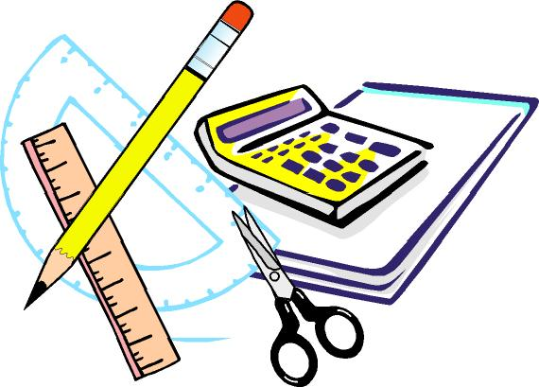
2 Pen, Red, Bic©, Ballpoint Stick
7 Pencil, #2, Ticonderoga©, Sharpened, Yellow
1 Pencils, Colored, 12ct, 7”(Long), Crayola©
1 Protractor, 6” Clear

1 Ruler, 12” Standard & Metric, Clear Plastic w/Holes
1 Scissors, 7”, Student Schoolworks by Fiskars©
1 Sharpie©, Black, Fine
1 Sharpie©, Black, Ultra Fine
1 Shoe Box, 6 qt Sterilite
2 Tissue, Kleenex©, Family Size
1 Watercolors, 8ct Prang©
1 Wipes, Clorox©, Disinfectant, 35ct
2 Rolls of Paper Towels

To be purchased at school: Headphones $5.00 (New Students Only), Assignment Notebook $4.00, Handbell Gloves $5.50 (New Students Only)

